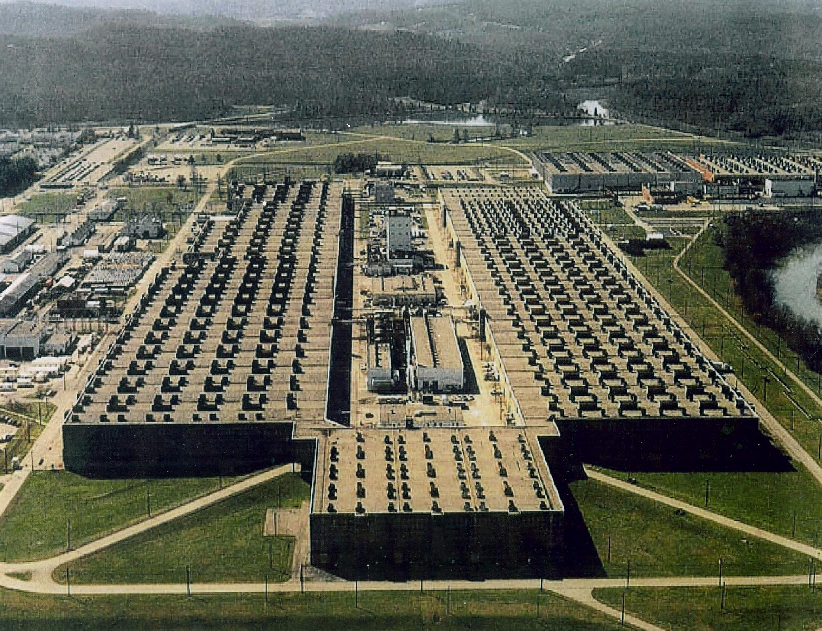  PKP Executive Committee  Bill Wilcox, Co-Chair  City Historian, Ret.Techn. Dir.  David Bradshaw, Co-Chair  ex-Mayor, SunTrust Bank  Cynthia Kelly, Co-Chair  President, AHFoundation  Margaret Allard,  Children's Museum  Gordon G. Fee  Ret. Pres. L.M.Energy Systems  Steve Goodpasture  Wheat Community, CDM  Howard Harvey  Ret. VP, REMOTEC Corp.  Keith McDaniel  Founder, Secret.City Films  Dave Miller  Oak Ridge Businessman  Jim Rogers  Wackenhut  D. Ray Smith  Y-12, Historian  Lloyd Stokes  Ret.ORNL, ORHPA-Govt. Aff.  Mick Wiest  Y-12, Cultural Resources  Program Administration & Development  Cynthia Kelly, AHF, Washington  Bill Wilcox, Oak Ridge | Partnership for K-25 Preservation (PKP)  Saving this Unique Heritage for Future Generations  102 Robertsville Road, Suite B, Oak Ridge, TN 37830  www.atomicheritage.org www.k25heritage.org  December 1, 2007  “THE K-25 REGISTRY”  We are compiling a list of folks who believe as we do that some small but significant part of the Historic K-25 "U" Building should be preserved so that future generations of heritage tourists and others can appreciate what a monumental achievement that plant, built on the site of the Wheat Community, was in WWII and how much it did for our Nation and the world in the Cold War and peacetime years since.  In order to gain the attention, interest, and active support of the DOE and our legislators, it’s important for us to show we have a base of support from the “community”, so we’ll much appreciate your joining with us as a Partner in this important venture. And this K-25 Registry will become a permanent part of our future exhibits at K-25, helping folks remember those thousands of you who had a part in making this vital history happen as well as our other loyal supporters. Will you please help by returning this form showing your support?  What Segment(s) of The Registry Apply?  (If spouse is different, please list them on reverse)  Name: __________________________ _____The General Public (I never worked there, but agree preservation is good idea)  Address: __________________________ _____ Wheat Community & Descendants  _____ Columbia Univ.– R&D Team  ___________________________ _____ Kellex – Design Team  _____ Construction  ___________________________ _____ Happy Valley – lived there  _____ S-50  E-mail (opt) _________________________ _____ ANP - Fairchild  Phone (opt) _________________________ _____ K-25 Powerhouse  _____ Special Engineer Detachment (SED)  _____ I worked There Sometime 1945 - 1985  _____ I helped with Close Out 1986 - 2009  Cordially,  Bill Wilcox, Cindy Kelly, Co-Chairs,  Partnership for K-25 Preservation  □ I’d rather not get any updates or further mailings.

